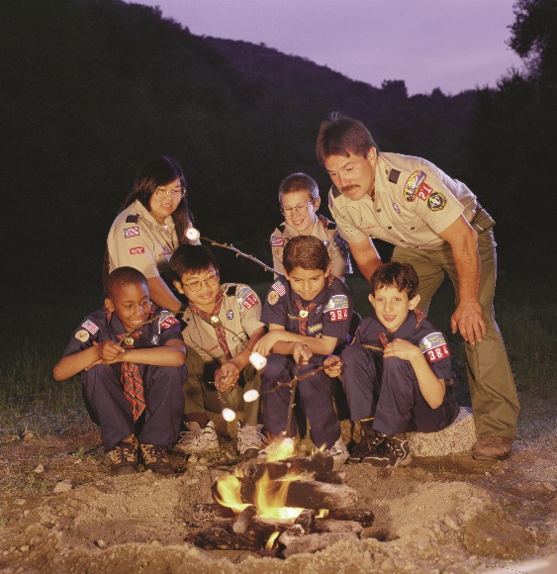

***You are cordially invited to attend the rescheduled   
Council Annual Dinner***

*Thursday, August 13, 2020*

*Treasure Valley Scout Reservation*

Please join us for an informal cook out and Annual Meeting at Treasure Valley. Preregistration is required in order for us to distribute safety information. We will meet and eat outside. We will follow all state guidelines to have a safe gathering. We ask that you consider a donation to cover the cost of the cookout. If weather or State Guidelines prohibit an effective gathering, we will change venue to a virtual meeting. All details will be sent by email per your registration. Due to this event being rescheduled, the venue and time of year, we will have a condensed program.

**Evening Highlights:**Silver Beaver Recognition – the highest award bestowed on a volunteer by the Council  
Venturing Leaders Award – awarded for outstanding leadership in Venturing  
Heart of Scouting Award – recognizing outstanding community members

**Evening Schedule:**  
 Dinner, Reports and Awards – 6:30 PM – 7:30 PM

**Council Annual Dinner Registration**

Make checks payable to: ***Heart of New England Council***

***Register by July 28th***

____ Yes, I can attend! I will have ____ number in my party attending. Please consider making a donation to help cover the cost of the cookout.

____ I cannot attend but have enclosed a donation to support the Scouting in Central Massachusetts.

Total Donation Enclosed: $_________________

Name(s) ______________________________________________________________________

E-Mail: _______________________________________________________________________

Sign up at online, at the Service Center, or mail to: 1980 Lunenburg Road, Lancaster, MA 01523

If you have any questions, contact Scott Rosengren at   
Scott.Rosengren@scouting.org or 508-752-3769

[www.heartofnewenglandbsa.org](http://www.heartofnewenglandbsa.org)