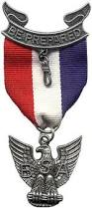
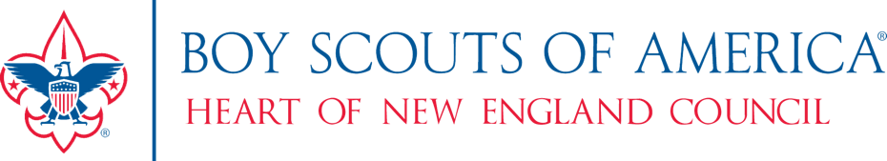

Eagle Scout Recognition Luncheon
Honoring the Members of the
Eagle Scout Class of 2019

To be held at the
La Salle Reception Center
444 Main Street
Southbridge, MA 01550

Saturday, January 11, 2020
11:00 am – 11:45 am: Check-In and Fellowship
Noon – 2:00 pm: Lunch and Program

Class of 2019 Eagle Scouts and their Scoutmasters attend at no cost
Family and Friends: $42 per person
(If you wish to sponsor an Eagle Scout or Scoutmaster, see link below or complete the additional sponsor form)

Space is limited – registration must be completed by December 20, 2019

Special dietary restrictions can be accommodated. Please see below.

To Register, please visit:
https://commerce.hnebsa.org/event/eagle-luncheon/
For Program information, please contact Paul Neslusan – paul_neslusan@msn.com
For Registration, Payment and Dietary Restrictions, please contact Kelly Stickney –kelly.stickney@scouting.org

